Customer Shopping Behavior Analysis

1. Project Overview
This project focuses on analyzing customer shopping behavior using transactional data consisting of 3,900 records across multiple product categories. The objective is to uncover meaningful insights into customer spending patterns, product preferences, discount effectiveness, and subscription behavior. These insights help businesses make data-driven decisions to improve revenue, marketing strategies, and customer engagement.

2. Problem Statement
Businesses often struggle to understand:
- Which customers generate the most revenue
- Whether discounts actually increase spending
- Customer purchasing patterns and loyalty behavior
- Product performance across categories
This project addresses these challenges by analyzing historical customer data and extracting actionable insights.

3. Dataset Summary
- Total Rows: 3,900
- Total Columns: 18

Key Features:
- Customer Demographics: Age, Gender, Location, Subscription Status
- Purchase Details: Item Purchased, Category, Purchase Amount, Season, Size, Color
- Shopping Behavior: Discount Applied, Promo Code Used, Previous Purchases, Frequency of Purchases
- Other Attributes: Review Rating, Shipping Type

Data Quality:
- Missing values found in Review Rating column (37 values)
- Handled using median imputation

4. Exploratory Data Analysis (EDA) using Python

Data Preparation & Cleaning
- Loaded dataset using Pandas
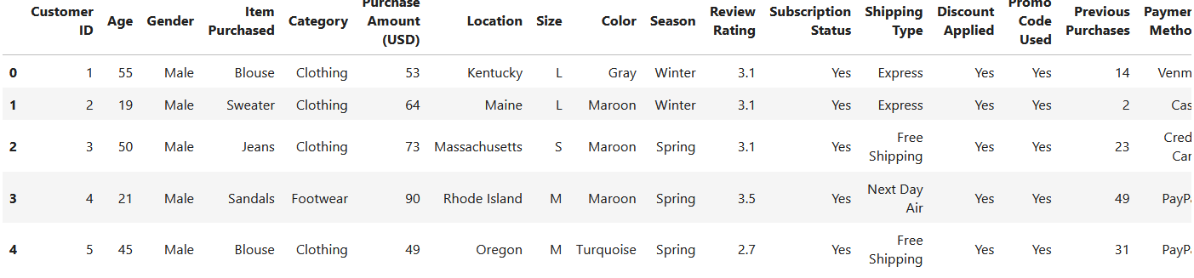
- Used df.info() to understand structure
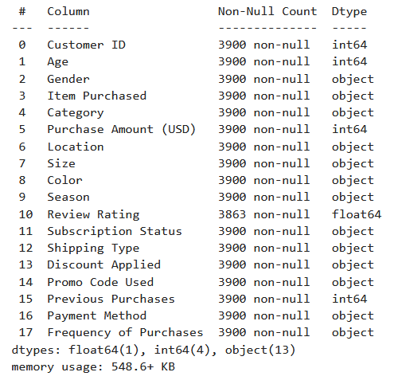
- Used df.describe() for statistical summary
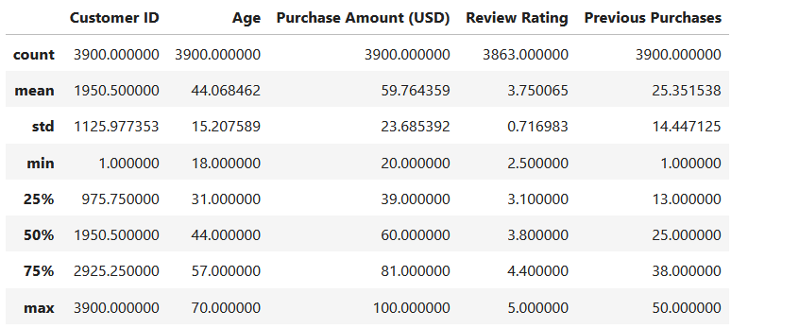

Data Cleaning Steps
- Handled missing values using median imputation
- Renamed columns to snake_case for consistency
- Removed redundant column (promo_code_used)

Feature Engineering
- Created age_group column (customer segmentation)
- Created purchase_frequency_days feature

Data Validation
- Checked consistency between discount_applied and promo_code_used
- Ensured clean and structured dataset for further analysis

5. Data Analysis using SQL (Business Questions & Insights)

Q1. Revenue by Gender
Analyzed total revenue generated by male and female customers to identify key revenue contributors.
Insight: Helps in targeting gender-specific marketing strategies.
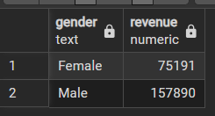

Q2. High-Spending Customers Using Discounts
Identified customers who used discounts but still spent above average.
Insight: Shows that discounts can attract high-value customers, not just low spenders.

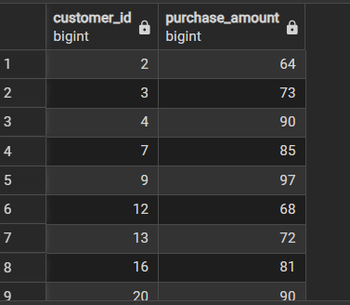

Q3. Top 5 Products by Review Rating
Calculated average ratings and ranked top-performing products.
Insight: Helps identify high-quality products that drive customer satisfaction.
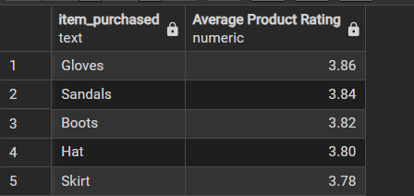

Q4. Purchase Behavior by Shipping Type
Compared average spending between Standard and Express shipping.
Insight: Reveals whether faster delivery influences higher spending.
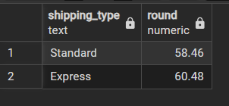

Q5. Subscriber vs Non-Subscriber Analysis
Compared total customers, average spend, and revenue.
Insight: Evaluates effectiveness of subscription programs.
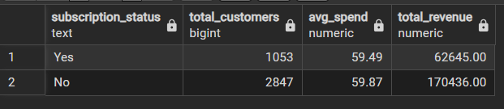

Q6. Products with Highest Discount Usage
Identified products most frequently purchased with discounts.
Insight: Highlights price-sensitive products.
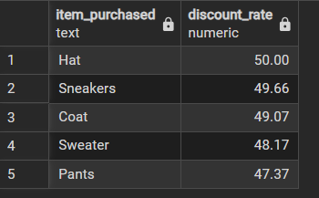

Q7. Customer Segmentation
Segmented customers into:
- New
- Returning
- Loyal
Insight: Helps in designing personalized marketing strategies.
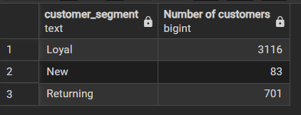

Q8. Top Products per Category
Ranked top 3 most purchased products within each category.
Insight: Identifies best-selling products across categories.
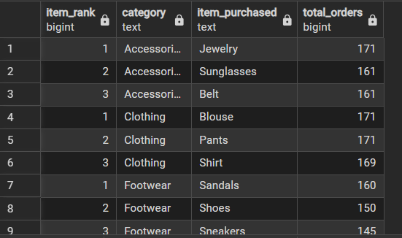

Q9. Repeat Buyers vs Subscription
Analyzed whether repeat customers are more likely to subscribe.
Insight: Helps in understanding loyalty and retention strategies.
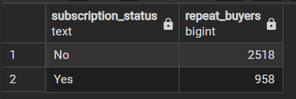

Q10. Revenue by Age Group
Analyzed which age groups contribute most to revenue.
Insight: Enables age-based targeting and product positioning.
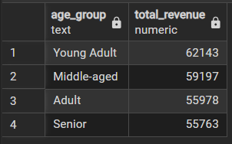

6. Dashboard (Power BI)
An interactive dashboard was created to visualize:
- Revenue trends
- Customer segmentation
- Product performance
- Subscription insights
- Discount impact
This helps stakeholders quickly understand key metrics and make informed decisions.
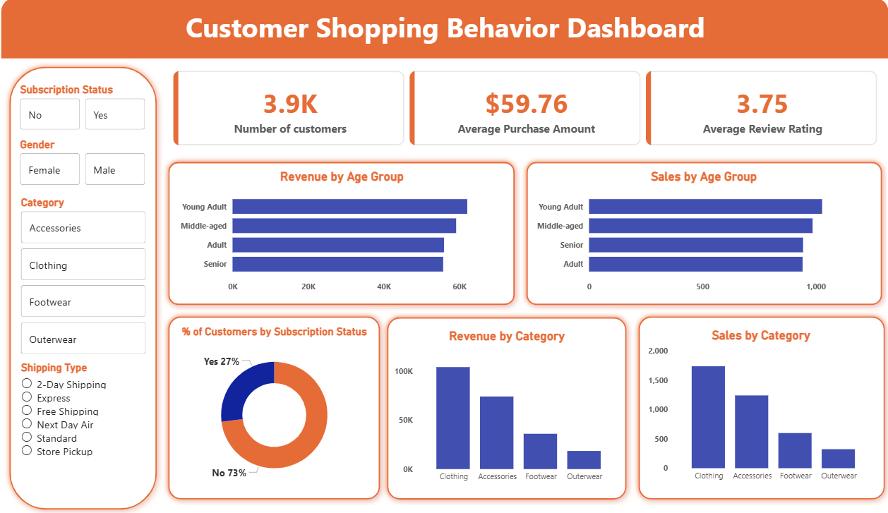

7. Key Insights
- Discounts attract both low and high-value customers
- Loyal customers significantly contribute to revenue
- Certain products consistently receive higher ratings
- Subscription-based customers tend to spend more
- Age and gender influence purchasing behavior

8. Business Recommendations

1. Optimize Discount Strategy
- Offer targeted discounts instead of blanket offers
- Focus on high-performing products

2. Improve Customer Retention
- Provide loyalty rewards for returning customers
- Encourage repeat purchases through personalized offers

3. Strengthen Subscription Programs
- Promote subscriptions with exclusive benefits
- Offer discounts or early access to subscribers

4. Focus on High-Performing Products
- Increase marketing for top-rated products
- Maintain quality to sustain ratings

5. Target High-Value Segments
- Focus campaigns on high-spending age groups
- Personalize marketing based on customer behavior

6. Enhance Delivery Experience
- Promote Express shipping if it correlates with higher spending

9. Conclusion
This project demonstrates how data analysis using Python, SQL, and Power BI can transform raw transactional data into meaningful business insights. The findings help businesses optimize pricing strategies, improve customer retention, and maximize revenue.

10. Tools & Technologies Used
- Python: Pandas, NumPy
- SQL: PostgreSQL
- Visualization: Power BI
- Techniques: Data Cleaning, EDA, Feature Engineering, Aggregation, Window Functions

